|  |
| --- |
| **18CSS202J - COMPUTER COMMUNICATION**  **SEMESTER - IV**  **ACADEMIC YEAR: 2022 – 2023**  **NAME OF CANDIDATE : SHUBHANGI SRIVASTAVA**  **REGISTER NUMBER : RA2011028010076**  **NAME OF CANDIDATE : SHANTANU SAHAY**  **REGISTER NUMBER : RA2011028010078**  **NAME OF CANDIDATE : DHAWAL GUPTA**  **REGISTER NUMBER : RA2011028010081**  **SECTION : K2**  **PROGRAM : B.TECH – CLOUD COMPUTING**  Logo, company name  Description automatically generated  **SCHOOL OF COMPUTING**  **DEPARTMENT OF COMPUTATIONAL INTELLIGENCE**  **SRM INSTITUTE OF SCIENCE AND TECHNOLOGY**  S.R.M NAGAR, KATTANKULATHUR – 603 |

|  |
| --- |
| **PROJECT ON:**  **CAMPUS NETWORK DEVICE USING**  **CISCO PACKET TRACER**  **(COMPUTER COMMUNICATION)**  **18CSS202J** |

**BONAFIDE CERTIFICATE**

Certified to be the bonafide project work done by SHUBHANGI SRIVASTAVA register no. RA2011028010076 and SHANTANU SAHAY register no. RA2011028010078 and DHAWAL GUPTA register no. RA2011028010081 of IV Semester B.Tech –Cloud Computing department in the Practical Course “18CSS202J - Computer Communication” in SRM Institute of Science and Technology, Kattankulathur, during the academic year 2022-2023.

Date: Course In-charge HOD/NWC

Submitted for the University examination held on ____________________ in the Department of Network and Communication, Faculty of Engineering and Technology, Kattankulathur.

Date: Examiner-I Examiner-II

ABSTRACT

Computer networks have a significant impact on the working of an organization. Universities depend on the proper functioning and analysis of their networks for education, administration, communication, e-library, automation, etc. An efficient network is essential to facilitate the systematic and cost-efficient transfer of information in an organization in the form of messages, files, and resources. The project provides insights into various concepts such as topology design, IP address configuration, and how to send information in the form of packets to the wireless networks of different areas of a University Campus.

The aim of this project is to design the topology of the university network using the software

Cisco Packet Tracer. This university network consists of the following devices:

1. Router (1941)

2. Switches (2960-24TT)

3. Email server

4. DNS server

5. WEB server (HTTP)

6. PCs

7. Laptops

The design includes the following parts of the University:

* University Building
* Tech Park
* Hospital Block

TABLE OF CONTENTS

|  |  |  |
| --- | --- | --- |
| 1. | Cover Page | 1 |
| 2. | Certificate | 2 |
| 3. | Abstract | 3 |
| 4. | Table of Contents | 4 |
| 5. | Introduction | 5 |
| 6. | Literature Review | 6 |
| 7. | Work Done | 10 |
| 8. | Results and Discussion | 25 |
| 9. | Conclusions | 29 |
| 10. | References | 30 |

INTRODUCTION

**Motivation -** The word “digital” is very significant in today’s world, with an increase in the development of technology the entire world is moving towards the digital era. The educational institution plays an important role in this digitalization hence the campus should adapt to digital means of networking as well and become a “digital campus”. A wired connection makes it easier to keep track of all the devices and to manage the cable connection.

Campus networking via reliable wired connection becomes an important part of campus life and provides the main way for teachers and students to access educational resources, which gives an important platform to exchange information. It provides an efficient way to explore the internet with a mobile terminal for teachers and students regardless of cables and places. With the development of network and communication technology, cable networks on a university campus bring much convenience for teaching and research work. But for mobility and flexibility, it has obvious shortcomings.

**Project Statement -In this mini project, we Design a computer network for a college. There are 50 users in the college. 20 users in the main building, 20 users in the annex campus tech park bldg , and 10 users in annex campus hospital block. Every building has a lobby which is 200 sqft open space, where wireless access to the network is required. Only authorized personal should have access to the wireless**

**network. The distance between annex campus hospital block and the main building is 300 mtrs. The**

**distance between annex campus tech park and the main building is 90 mtrs. The distance**

**between annex campus hospital block and tech park is 70 mtrs. A high speed cable internet**

**connection is available in the main building which needs to be shared among the users.**

**The necessary equipments and appropriate topology required for the campus network design**

**along with the IP address schema, IP address management, secure wireless access, internet**

**sharing, features and services should be worked out. A bill of material should be included**

**with products from Microsoft, Cisco, D-LINK or Netgear**

LITERATURE REVIEW

**What is Packet Tracer?**

Packet Tracer is a cross-platform visual simulation tool designed by Cisco Systems that allows users to create network topologies and imitate modern computer networks. The software allows users to simulate the configuration of Cisco routers and switches using a simulated command-line interface. Packet Tracer makes use of a drag-and-drop user interface, allowing users to add and remove simulated network devices as they see fit. The software is mainly focused on Certified Cisco Network Associate Academy students as an educational tool for helping them learn fundamental CCNA concepts. Previously students enrolled in a CCNA Academy program could freely download and use the tool free of charge for educational use.

**Router** - A router is a device like a switch that routes data packets based on their IP addresses. The router is mainly a Network Layer device. Routers normally connect LANs and WANs together and have a dynamically updating routing table based on which they make decisions on routing the data packets. Router divides broadcast domains of hosts connected through it.

**Switch** – A network switch (also called switching hub, bridging hub, officially MAC bridge is networking hardware that connects devices on a computer network by using packet switching to receive and forward data to the destination device.

**Network Packet** – A network packet is a formatted unit of data carried by a packet-switched network. A packet consists of control information and user data, which is also known as the payload.

**Server** – A server is a computer or system that provides resources, data, services, or programs to other computers, known as clients, over a network. In theory, whenever computers share resources with client machines they are considered servers. There are many types of servers, including web servers, mail servers, and virtual servers. Many networks contain one or more of the common servers. The servers used in our project are as follows:

* **DNS Server** - DNS stands for Domain Name System servers which are application servers that provide a human-friendly naming method to the user computers in order to make IP addresses readable by users. The DNS system is a widely distributed database of names and other DNS servers, each of which can be used to request an otherwise unknown computer name.
* **WEB Server** - One of the widely used servers in today’s market is a web server. A web server is a special kind of application server that hosts programs and data requested by users across the Internet or an intranet. Web servers respond to requests from browsers running on client computers for web pages, or other web-based services.
* **EMAIL Server** - An e-mail server is a server that handles and delivers e-mail over a network, using standard email protocols.

**Computing Device** - Computing devices are the electronic devices that take user inputs, process the inputs, and then provide us with the end results. These devices may be Smartphones, PC Desktops, Laptops, printer, and many more.

**Internet Protocol** - Internet Protocol (IP) is one of the fundamental protocols that allow the internet to work. IP addresses are a unique set of numbers on each network and they allow machines to address each other across a network. It is implemented on the internet layer in the IP/TCP model.

WORK DONE

In order to make our project understandable, we have divided the content into steps. They are as follows:

1. **Software and hardware requirements**

* A proper workstation (any mid-high range laptop will suffice).
* Packet Tracer by Cisco
* 8 GB RAM.
* Any 10,000+ Average CPU Mark scored processor.
* 16 GB of dedicated hard disk space.
* USB 3.0+ port.

1. **Brief knowledge about our approach**

The proposed wired network is implemented for a university campus. We have made a virtual visualization of the network using the Cisco Packet tracer which provides a huge platform for users to test their projects using simulation tools. A Wired network in an educational campus makes it easier for teachers and students to access educational resources, by enabling an important platform to exchange information.

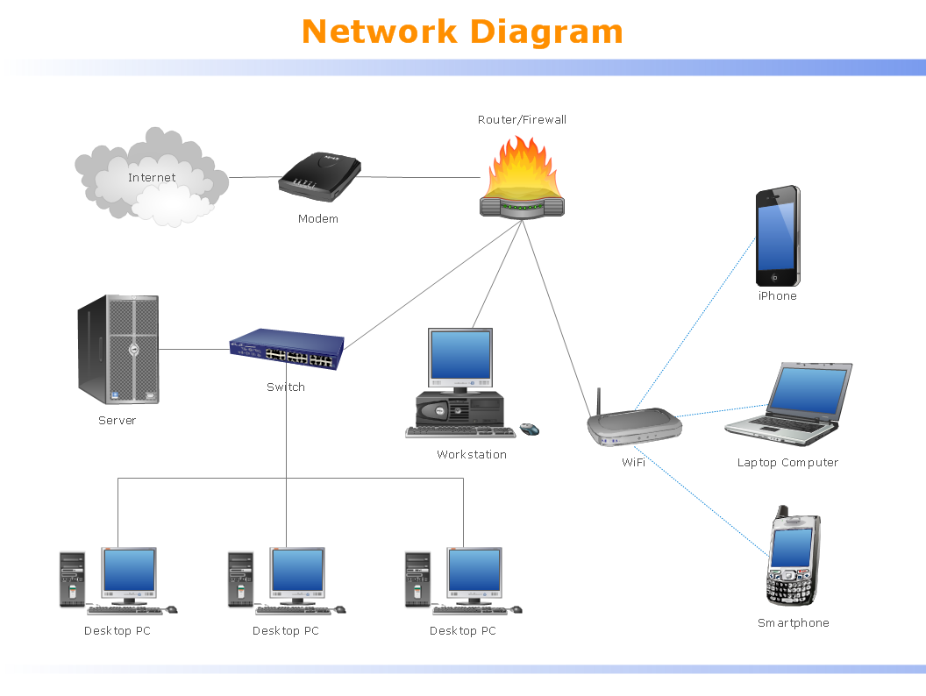

Figure 1: Shows the wired connection access by various tools

1. **Network Requirements**

SRMIST KTR outline is considered for this wired university network. The network is divided into 2 areas:

1. University Building – It is further divided into various subareas like DSA, Central Library, Academic Blocks (UB1219 and UB1221), University Lab.
2. Hostel Campus - The Hostel area is further divided into Men’s Hostel and Men’s Gym and Women’s Hostel and Women’s Gym respectively.
3. **Devices Used in the network**

|  |  |
| --- | --- |
| **Devices** | **Quantity** |
| 1) Router (1941) | 3 |
| 2) Switches (2960-24TT) | 15 |
| 3) EMAIL server | 1 |
| 4) DNS server | 1 |
| 5) WEB server (HTTP) | 1 |
| 6) PCs | 44 |

**Implementation and Flow Diagram**

* To design the wired network of the university building we initially started by placing the core devices into the frame as mentioned in the layout.
* Firstly, we placed the **main router** at the center of the university outline, which was further connected to the **server switch** using copper straight-through cable and sub routers (**campus router and hostel router**) using the serial port with serial DCE cable at the hostel area and campus area respectively.
* The server switch was further connected to the **EMAIL, DNS, and WEB** servers respectively.
* Campus router was connected to the campus switch which was further connected with wireless access points of the academic block (**classroom UB1219 and UB1221**), **University Lab**, Central L**ibrary,** and **DSA.**
* The wired access points were then connected to computing devices (PCs). Similarly, the hostel router was connected to the hostel and gym switches which were further connected with the wired access point of Men’s and Women’s block.
* All these connections are made through ethernet ports (gigabit ethernet and fast ethernet) using copper straight-through cables.

**Configuring IP Addresses**

Main Router configuration

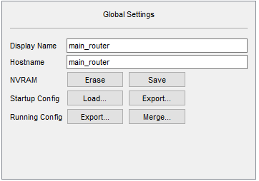

GigabitEthernet0/1

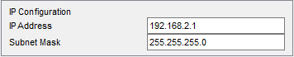

Serial0/1/0

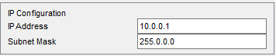

Serial0/1/1

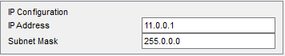

RIP

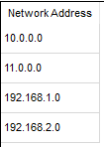

DNS SERVER

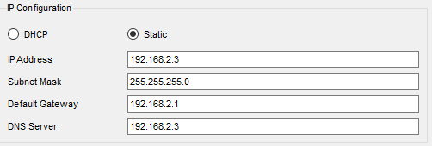

WEB SERVER

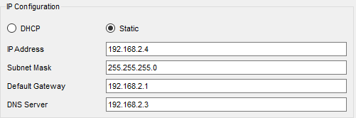

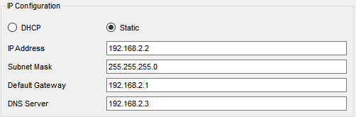EMAIL SERVER

COLLEGE ROUTER

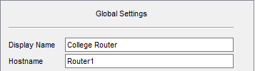

RIP

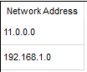

GigabitEthernet0/0

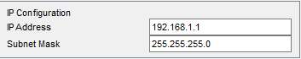

Serial0/1/0

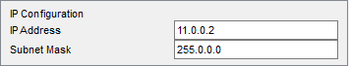

IP Configurations:

* ACADEMIC BLOCK UB1221:

IP Address are as follows

192.168.1.10- Laptop

192.168.1.11- PC

192.168.1.12- Laptop

192.168.1.13- PC

Subnet Mask- 255.255.255.0

Default Gateway- 192.168.1.1

DNS Server- 192.168.2.3

* ACADEMIC BLOCK UB1219:

IP Address are as follows

192.168.1.14- Laptop

192.168.1.15- PC

192.168.1.16- Laptop

192.168.1.17- PC

Subnet Mask- 255.255.255.0

Default Gateway- 192.168.1.1

DNS Server- 192.168.2.3

* CENTRAL LIBRARY:

IP Addresses are as follows

192.168.1.5- PC

192.168.1.6- PC

Subnet Mask- 255.255.255.0

Default Gateway- 192.168.1.1

DNS Server- 192.168.2.3

* UNIVERSITY LAB:

IP Addresses are as follows

192.168.1.2- PC

192.168.1.3- PC

192.168.1.4- Laptop

Subnet Mask- 255.255.255.0

Default Gateway- 192.168.1.1

DNS Server- 192.168.2.3

* DSA

IP Addresses are as follows

192.168.1.7- Laptop

192.168.1.8- PC

192.168.1.9- PC

Subnet Mask- 255.255.255.0

Default Gateway- 192.168.1.1

DNS Server- 192.168.2.3

HOSTEL ROUTER

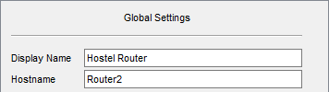

RIP

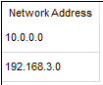

GigabitEthernet0/0

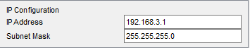

Serial0/1/0

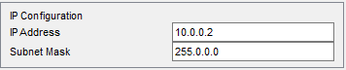

IP Configurations

* Women’s Gym

IP Addresses are as follows

192.168.3.12- PC

192.168.3.13- Laptop

Subnet Mask- 255.255.255.0

Default Gateway- 192.168.3.1

DNS Server- 192.168.2.3

* Men’s Gym

IP Addresses are as follows

192.168.3.10- PC

192.168.3.11- Laptop

Subnet Mask- 255.255.255.0

Default Gateway- 192.168.3.1

DNS Server- 192.168.2.3

* Women’s Hostel

IP Addresses are as follows

192.168.3.2- PC

192.168.3.3-Laptop

192.168.3.4- PC

192.168.3.5- Smartphone

Subnet Mask- 255.255.255.0

Default Gateway- 192.168.3.1

DNS Server- 192.168.2.3

* Men’s Hostel

IP Addresses are as follows

192.168.3.6- PC

192.168.3.7-Laptop

192.168.3.8- PC

192.168.3.9- Smartphone

Subnet Mask- 255.255.255.0

Default Gateway- 192.168.3.1

DNS Server- 192.168.2.3

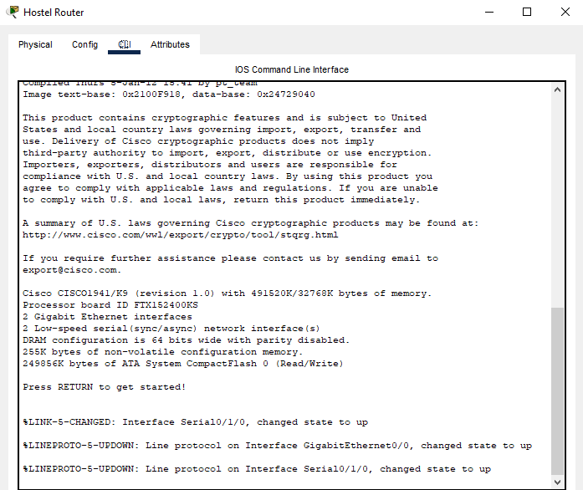

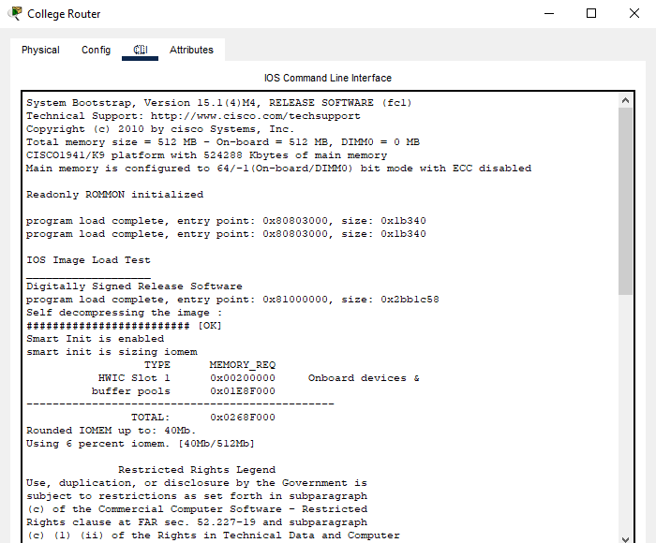

RESULT & DISCUSSION

Finally, we have combined all the steps as mentioned ‘work done’ and implemented the desired wireless network for university, we have the complete network providing various facilities to the teaching staff, non-teaching staff, and students.

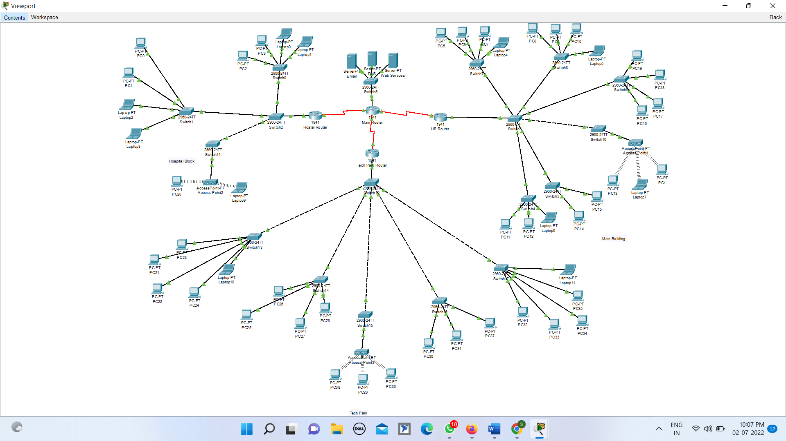

**The complete diagram of the University Campus Network Scenario created in Packet Tracer environment**

**Ping Test:** Network connectivity and communication can be tested using the ping command, followed by the domain name or the IP address of the device (equipment) whose connectivity one wishes to verify.

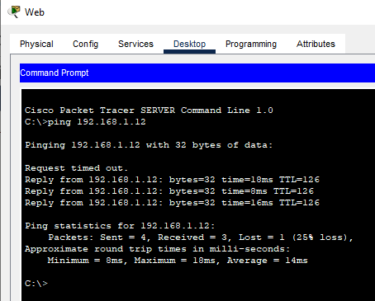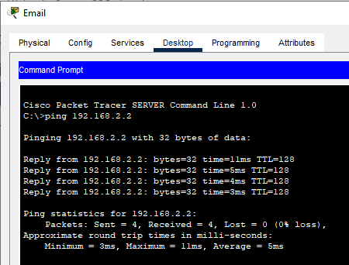

Ping Test for EMAIL server

Ping Test for WEB server



Ping Test for WEB server

CONCLUSION

We started our discussion with the word “digitalization” and in order to achieve it, we aimed to start with an educational institute, and finally, we designed a network for a university, which is wired. As we mentioned, reliability and efficiency are the key aspects of wireless networks, which were our main goal.

In this project, we designed a university network using Cisco Packet Tracer that uses a networking topology implemented using servers, routers, switches, and end devices in a multiple area network. We have covered all the necessary features that are required for a network to function properly. We have included a DNS server and a web server for establishing a smooth communication system between different areas of our network and specifically for the communication between students and teachers. We have included an email server to facilitate intra university communication through emails within the domain.

REFERENCES

<https://en.wikipedia.org/wiki/Packet_Tracer>

<https://www.paessler.com/it-explained/server>

<https://computernetworking747640215.wordpress.com/2018/07/05/secure-shell-ssh-configuration-on-a-switch-and-router-in-packet-tracer/>